

# Sri Lanka Institute of Information Technology

Data Warehousing & Business Intelligence

New York City Taxi Trips

Assignment 2

**Submitted By:**

IT16058156-D.R.A Kumarage

**Submitted To:**

Mr.Sheron Dinushka

**Step 1: Data Source Selection**

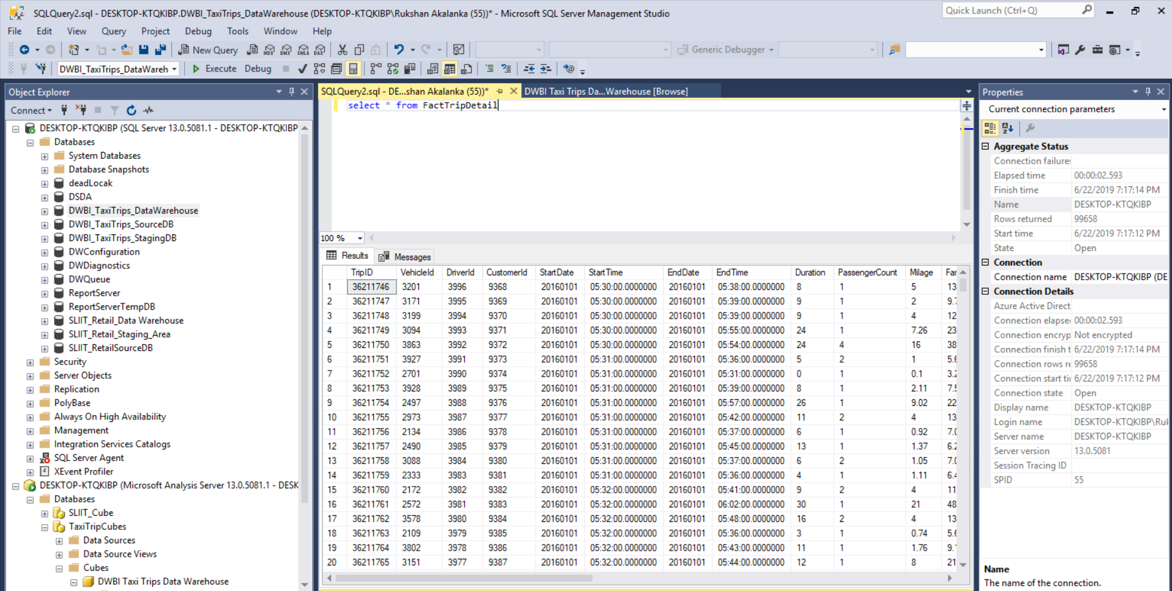

This Data set include records Taxi Trip Details in New York City 2016.

A Data warehouse has been created previously, with a fact table containing Trip details.

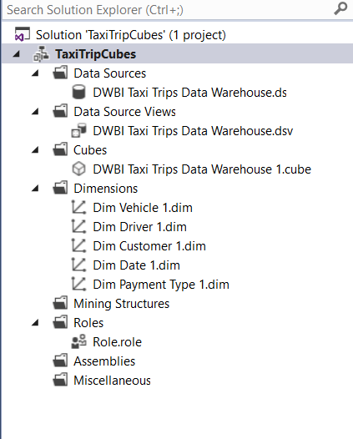

**Step 2: SSAS Cube Implementation**

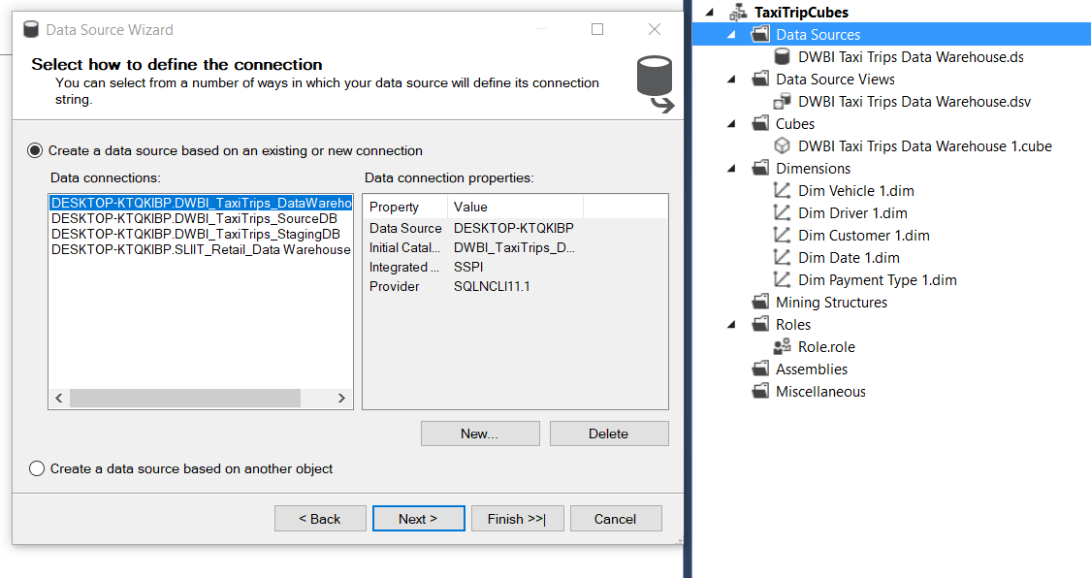

Using the Data Source View Wizard a View has been created for the Selected Data Source.

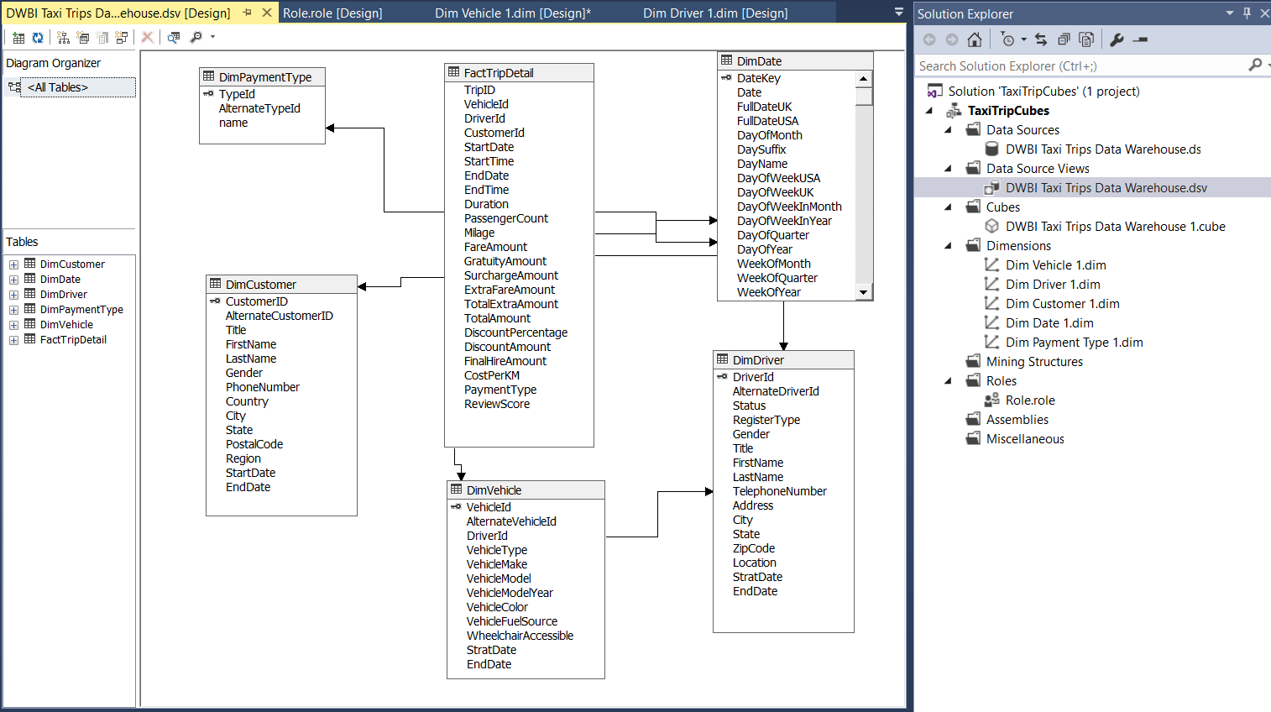

(Data Source View is highlighted)

Using Cube Wizard we select the measure group table that is needed to create the cube.

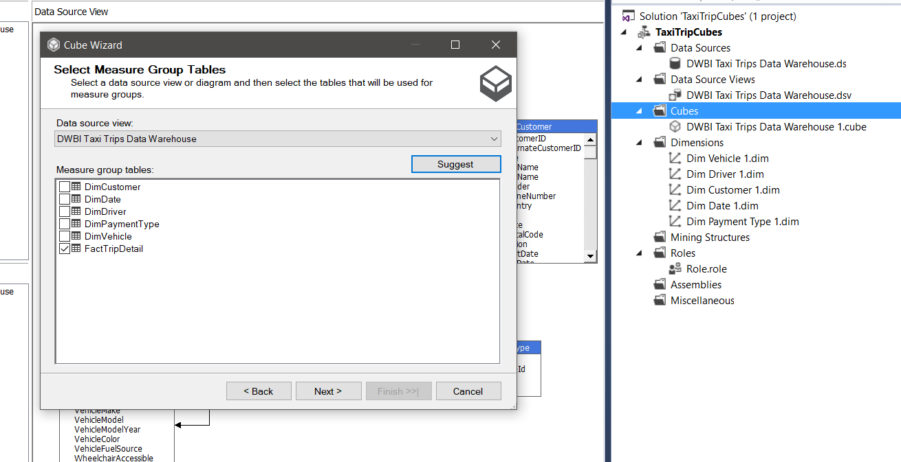

Using the Cube Wizard a new data cube is created.

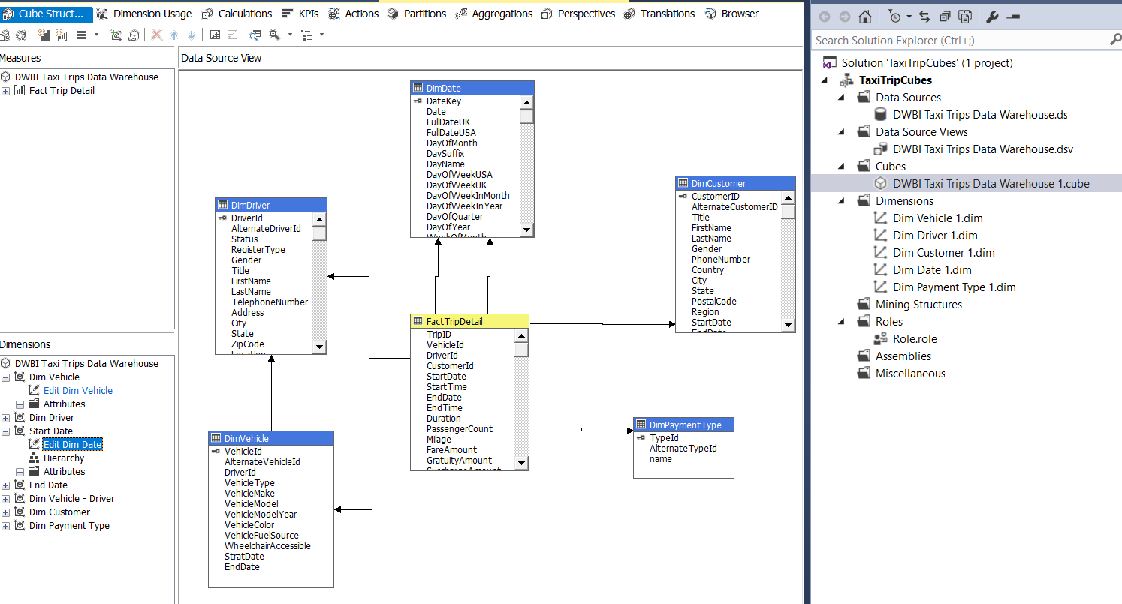

(Cube is highlighted in yellow color)

Even though we created the cube, only Primary Keys of the both Dimensions are selected. Therefore we have to configure them.

Then all the other attributes are dragged and dropped into the ‘Attributes’ to create the cube that we wanted.

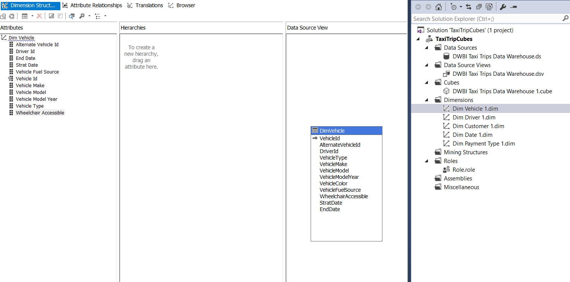

**Creating Hierarchies**

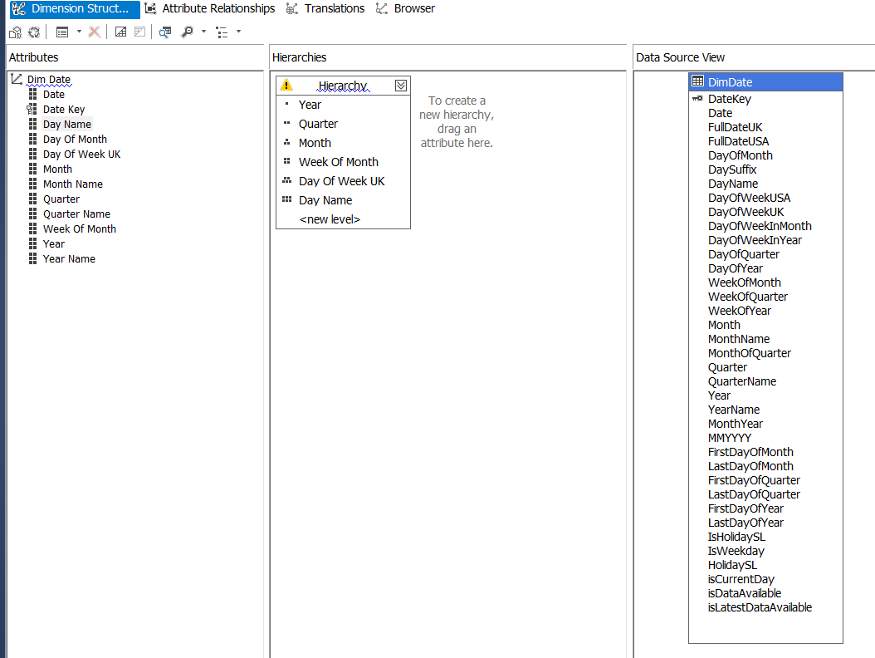

Here a Hierarchy has been created using Region And Date.

After saving, the hierarchy can be deployed and tested as in the below figures.

**Region Wise**

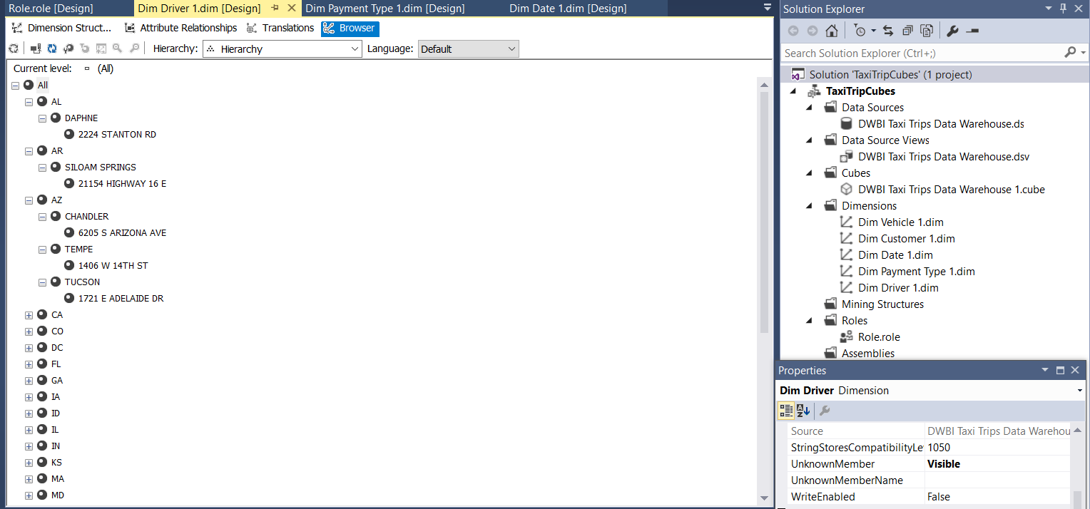

**Date Wise**

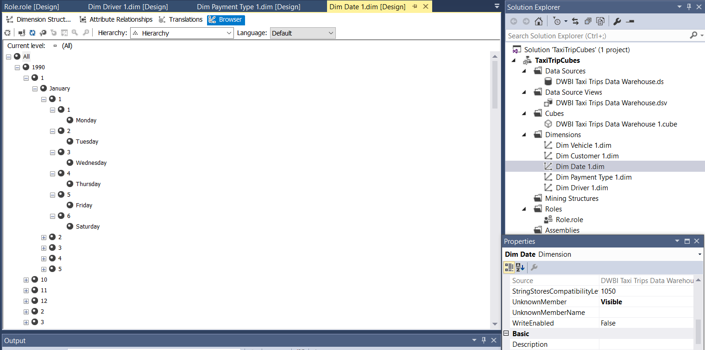

**Deploying the Cube**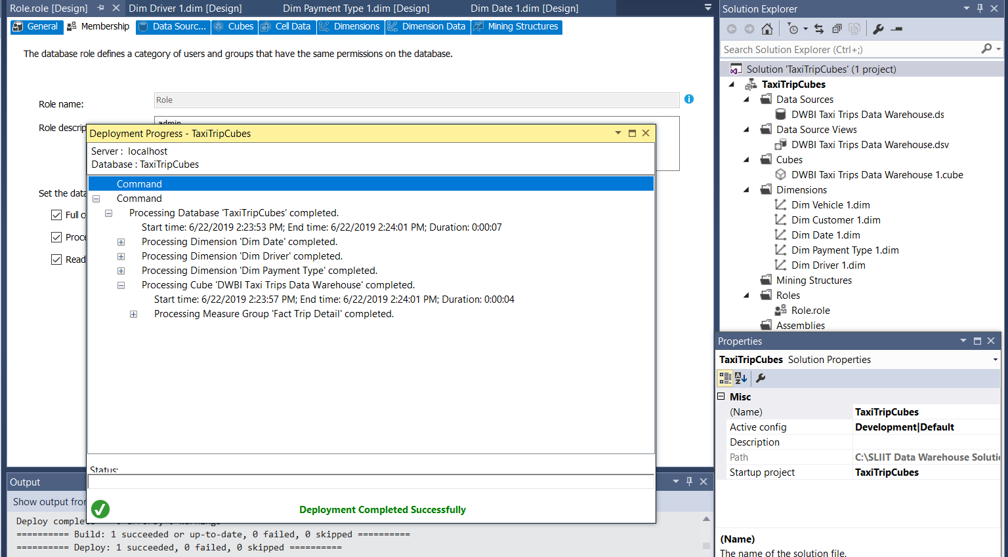

Here after deploying the solution, hierarchy can be checked with the measures.

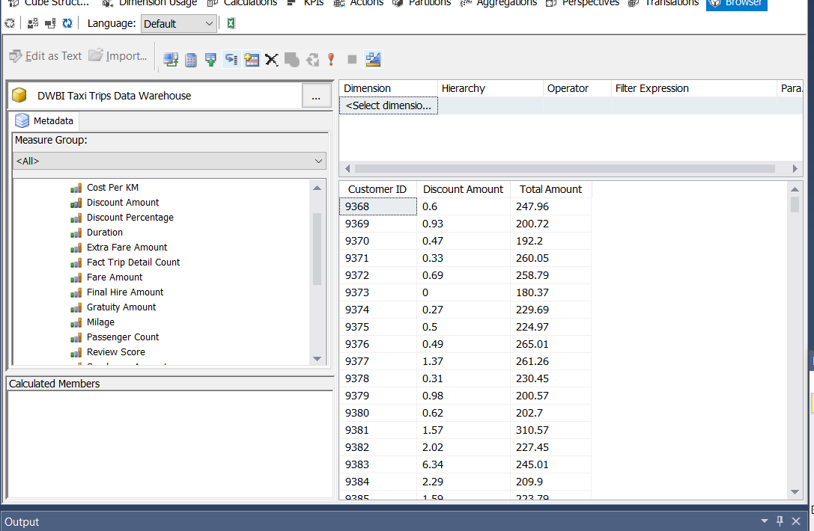

I have created a Role for the Cube

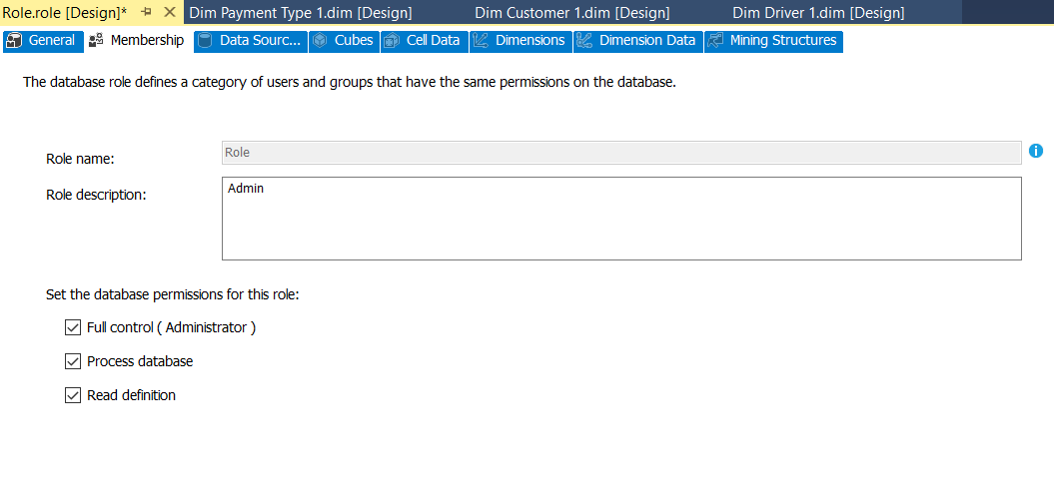

**Step 3: OLAP Operations using Powerpivot**

Attributes are selected and a query is generated to use in Powerpivot. Here you have to select the data that you want to extract and display.

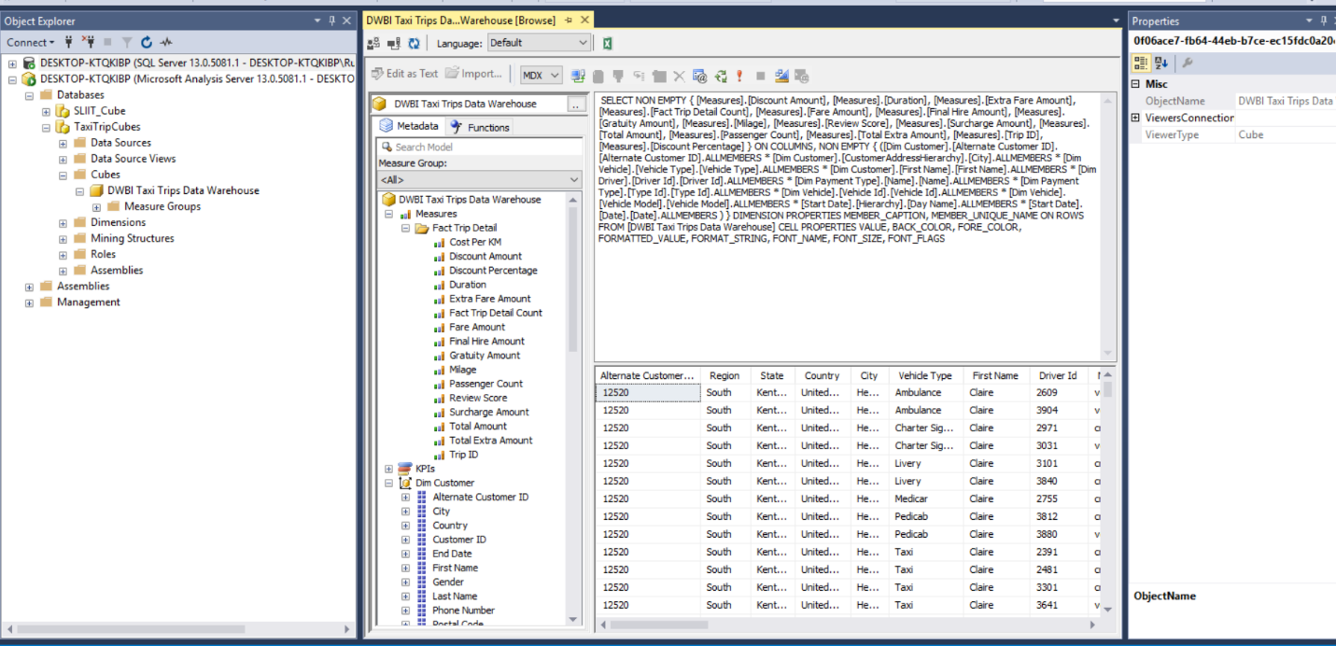

A connection for the Cube that we created is made in using Powerpivot in Excel.

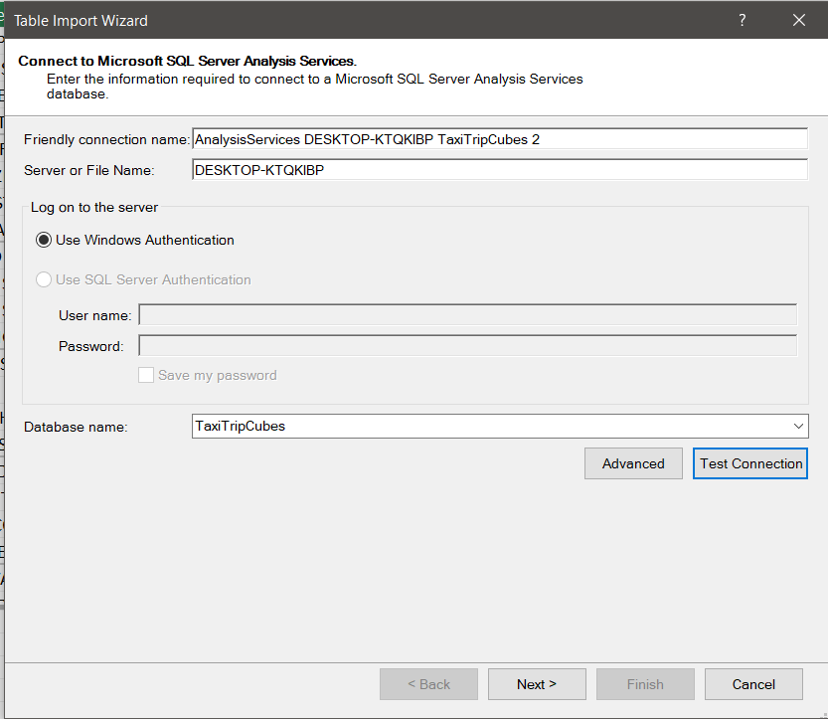

Query that we generated is pasted and validated.

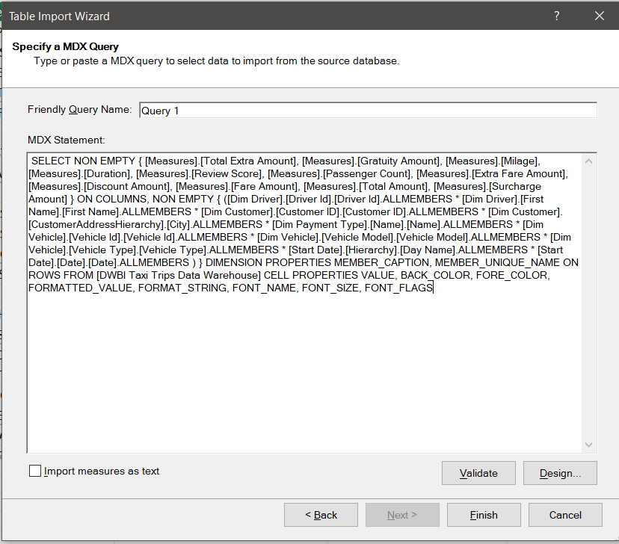

Data is extracted and loaded into the PowerPivot using the query generated before.

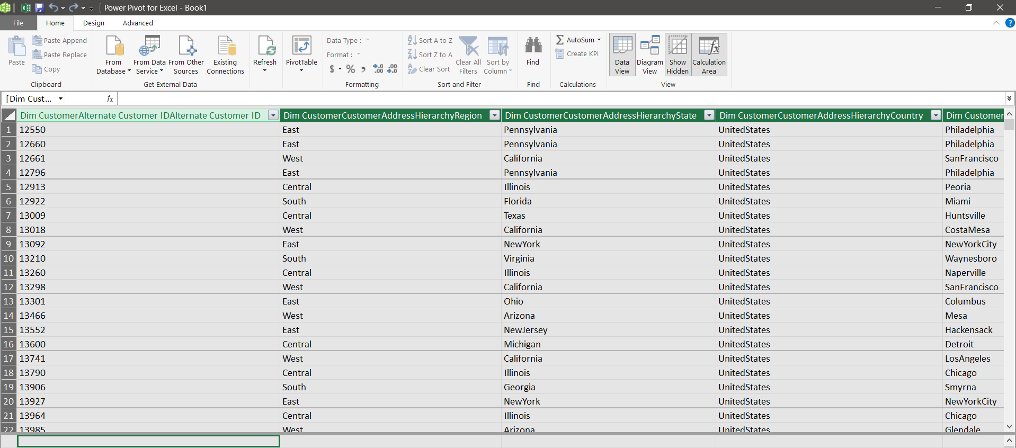

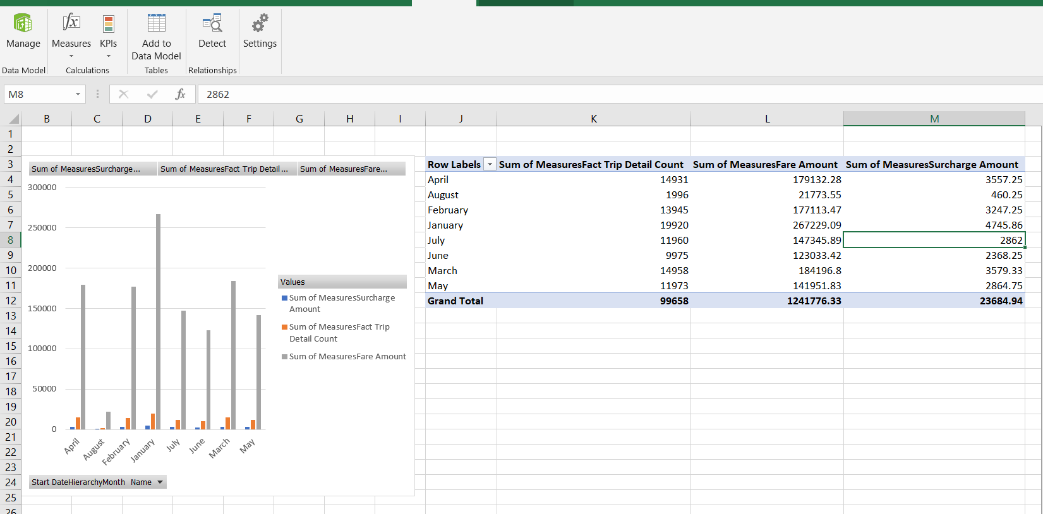Sum of trip count, Fare amount, Service Amount is displayed in month wise and they are displayed in both chart and pivot table. Here we can select any record we selected and display them the way we want.

**OLAP Operations**

**Drill Down**

Here the data is selected according to Date hierarchy (Year->Month->week of month ->Day).

Here it is drilled down in the hierarchy to display the trip count, total mileage, total amount and service chage.

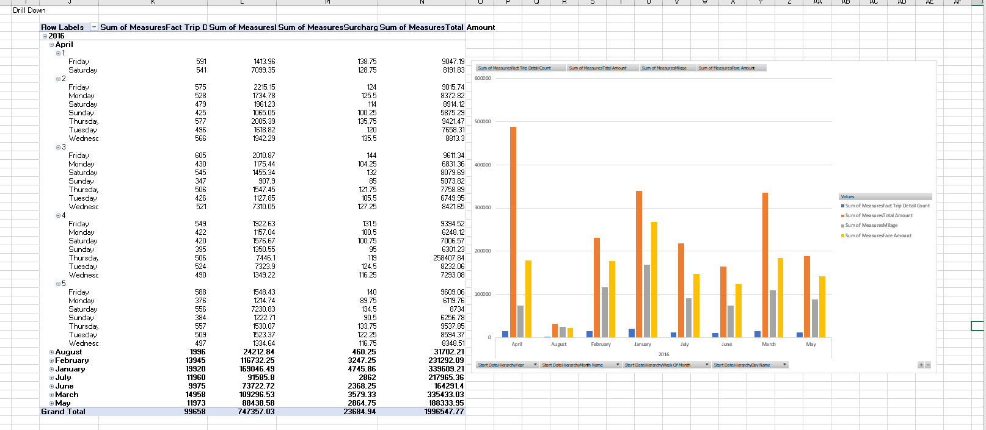

**Roll Up**

Here the data is Rolled Up in the hierarchy to display the trip count, total mileage, total amount and service chage.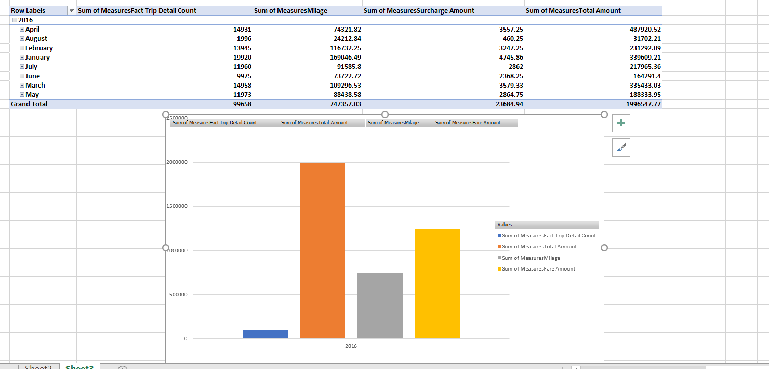

**Slicing**

Here Slicing is done Using Payment type for trip count, total Extra amount, total amount and service chage.

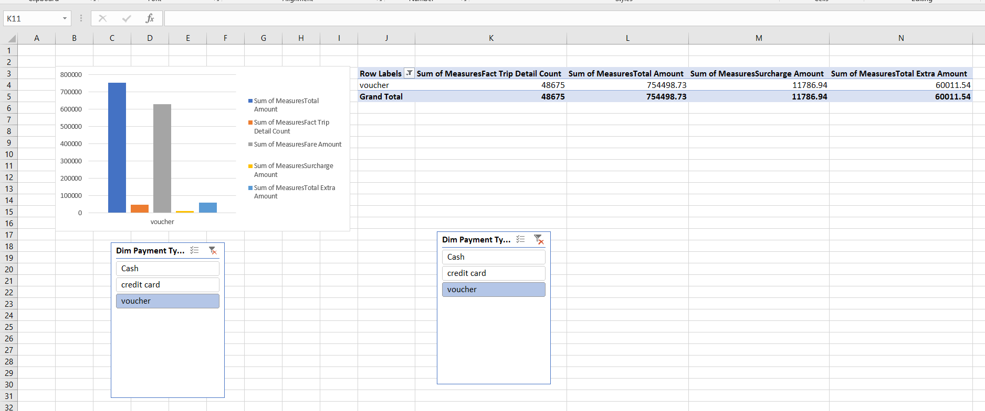

**Dicing**

Dicing is done using more than two dimensions. Dicing can be done using as many dimensions as the user want. Here Dicing is done using Region and month Wise total amount , trip count and fare amount.

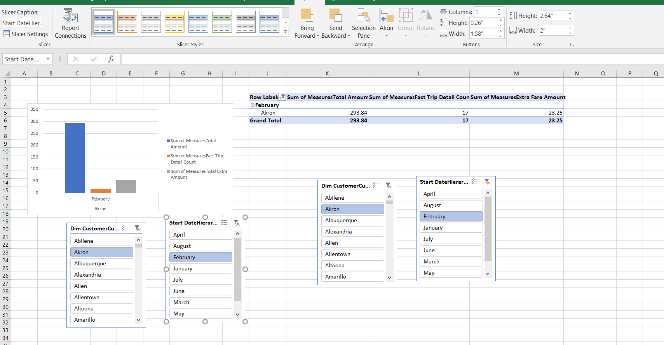

**Step 4: SSRS Report**

**Report 1: Matrix Report**

**A Matrix is created by using the data that we loaded to the warehouse before.**

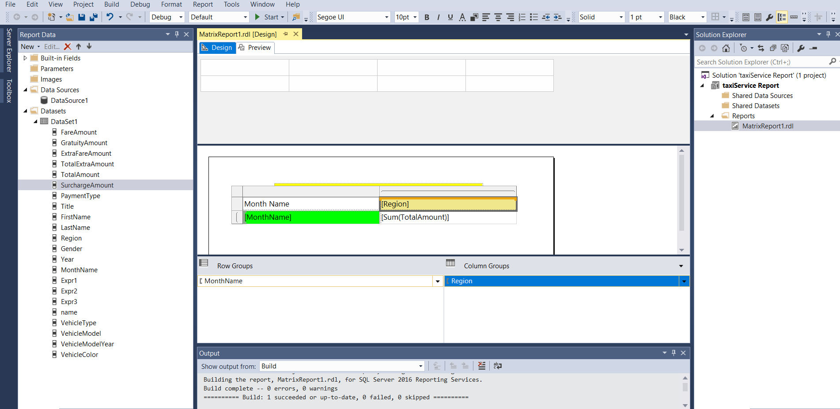

Preview of the Matrix Report

Retrieve the total hire amount according to month vs region

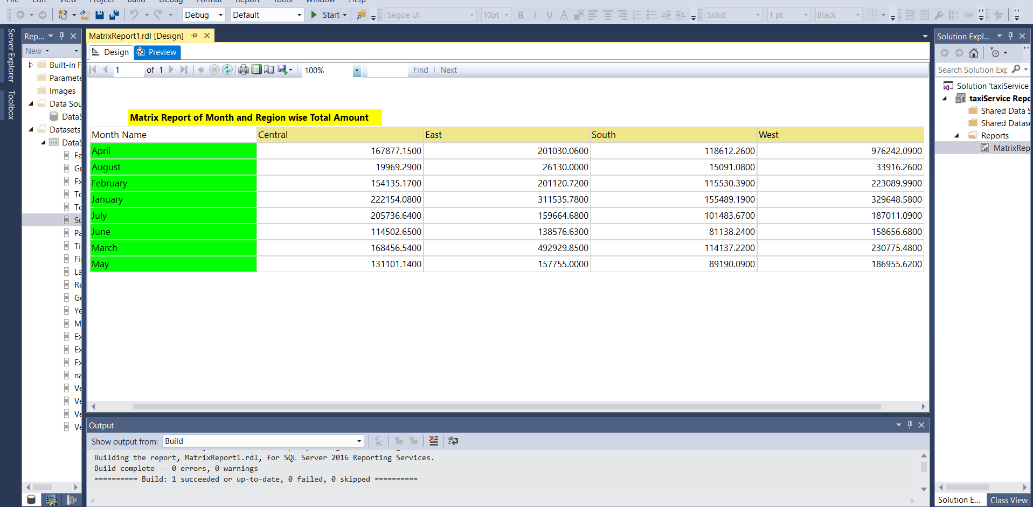

Matrix Report is deployed in Web Portal

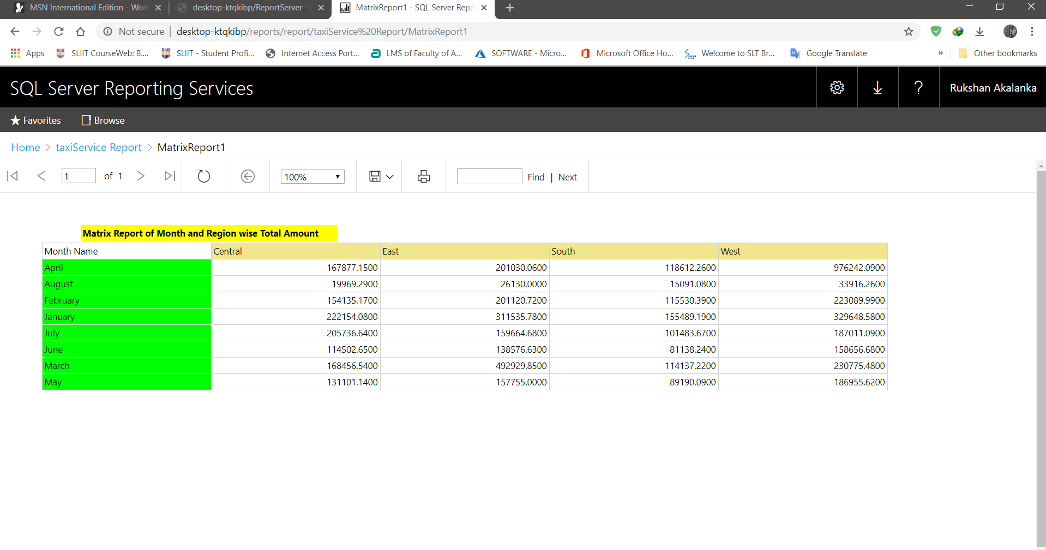

**Report 2: Reports with Multiple Parameters**

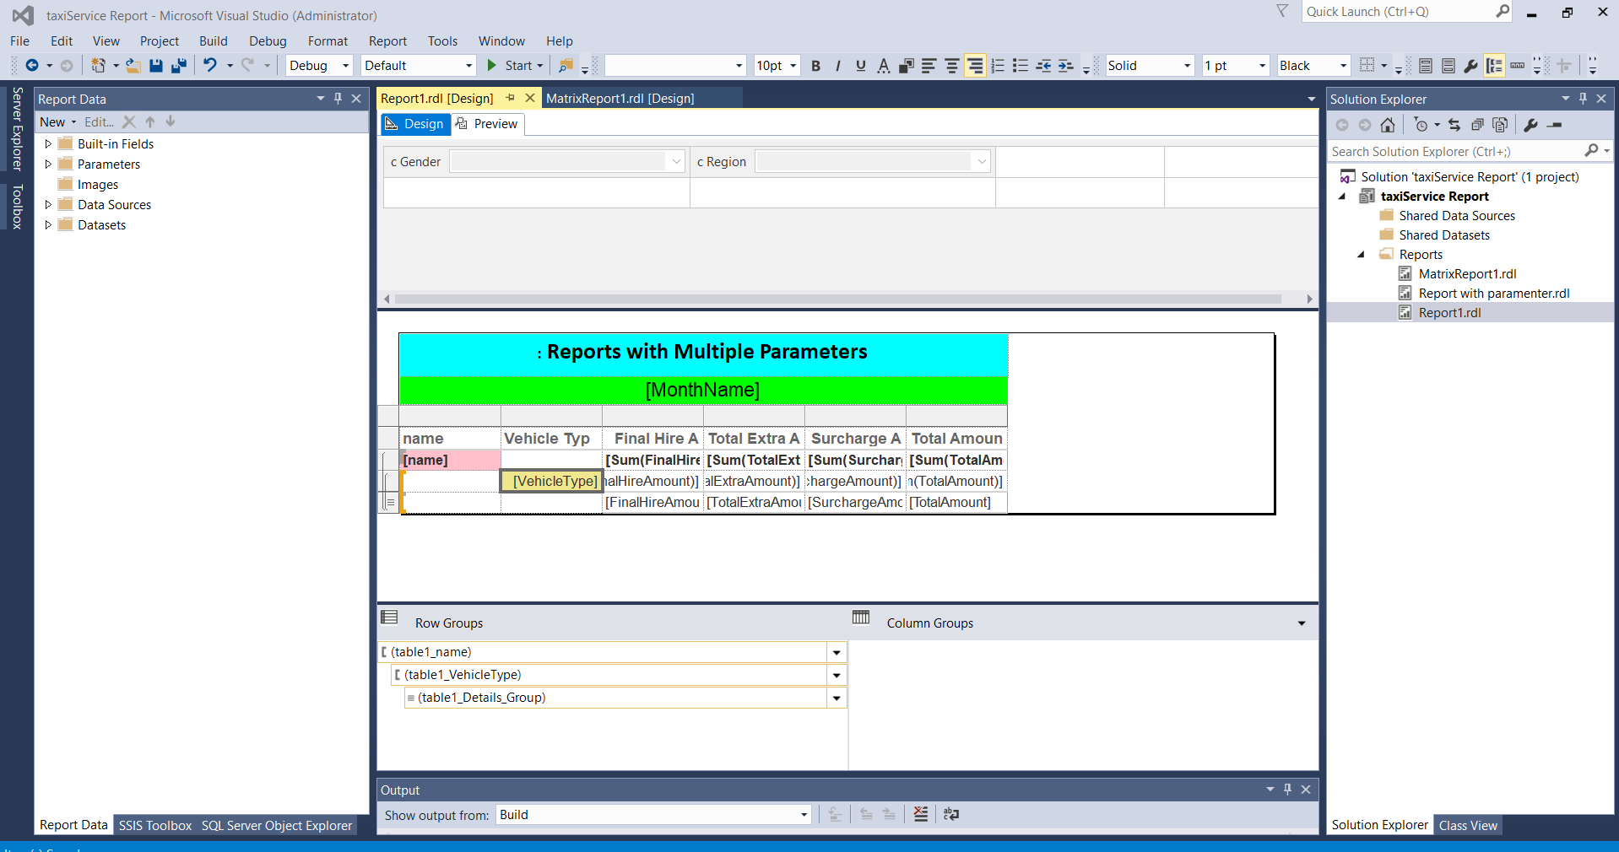

\

Data Using Two Parameters

All the measures of different payment type are filtered by customer region and customer gender

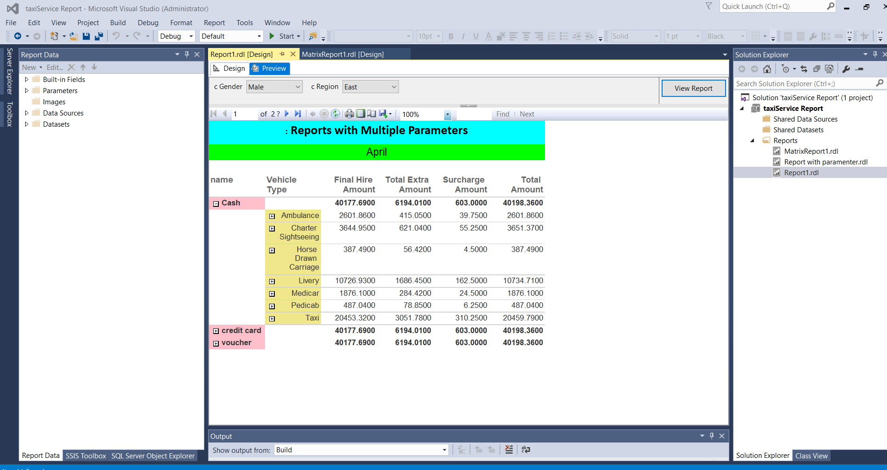

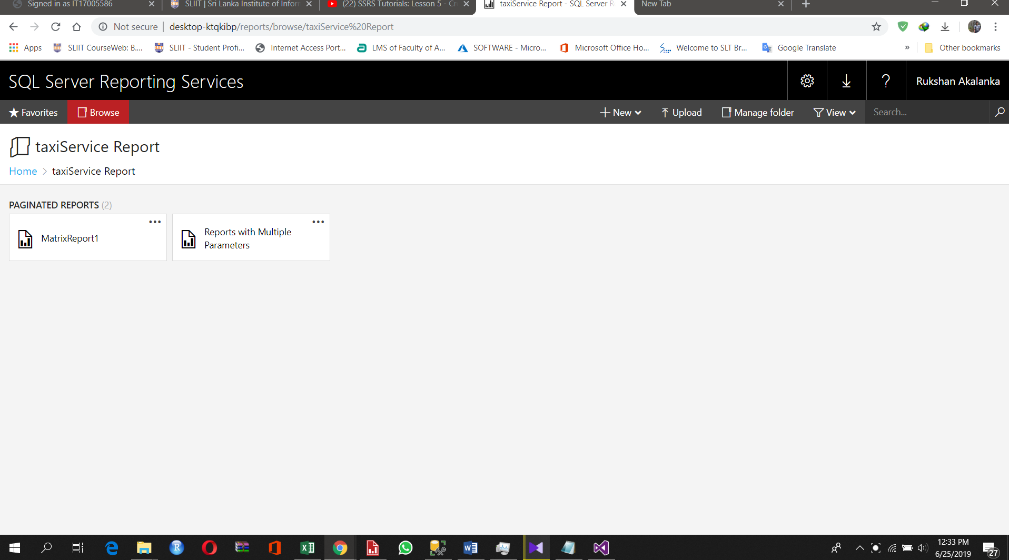Deployed to Web Portal

**Report 3: Drill-Down Report**

Drill Down was done using SSRS

Total hire amount, company service charge, total discount like wise all the measures are drilled down according to YEAR -> MONTH -> WEEK OF MONTH -> DAY OF WEEK

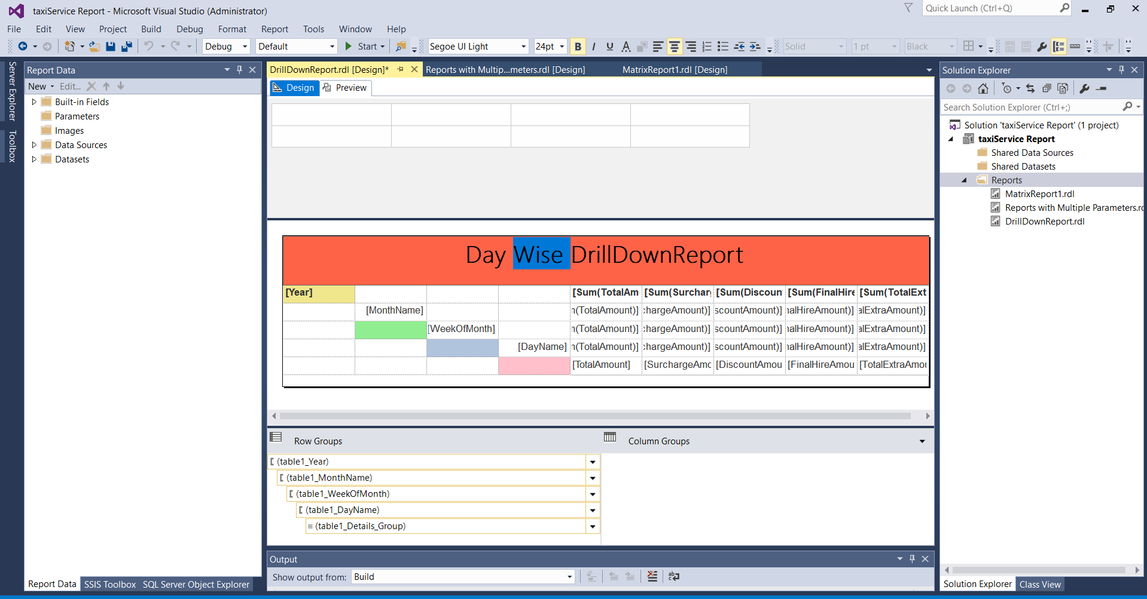

Drill Down data

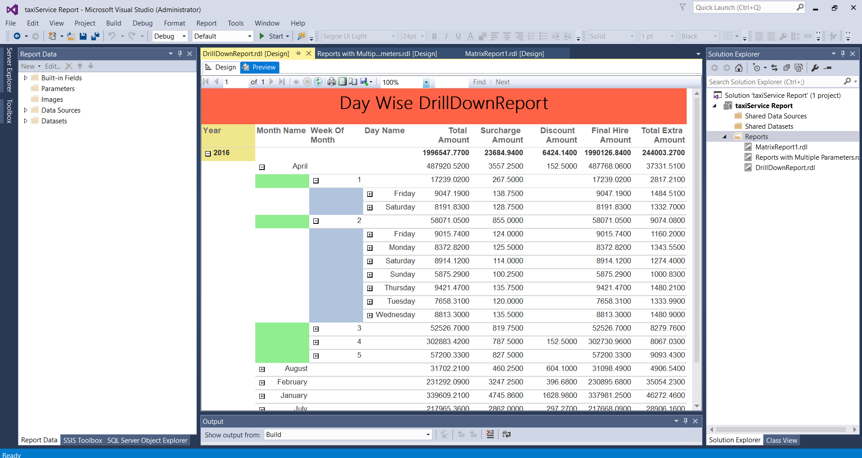

Deployed to Web Portal

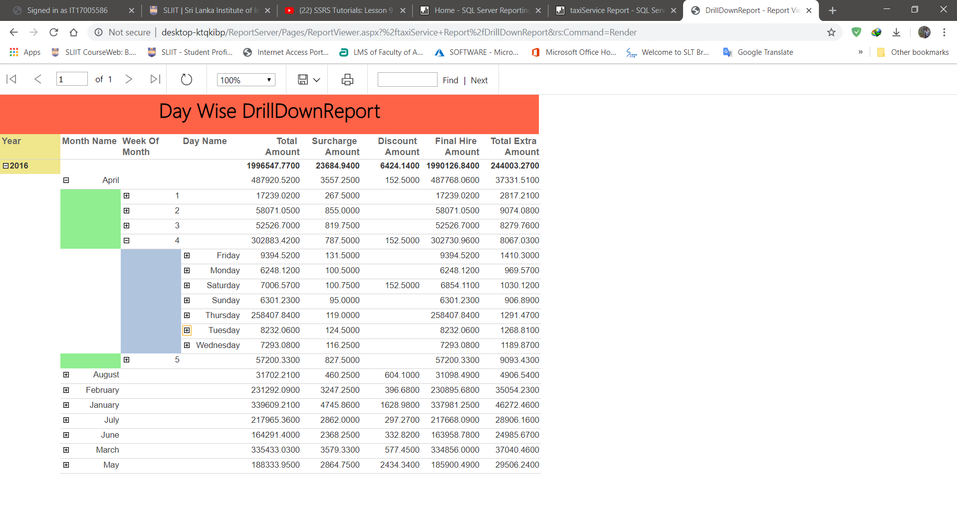

**Report 4: Drill Through**

Report provide all the drivers’ name and Driver ID. When click on the each driver’s name it take you to a another report.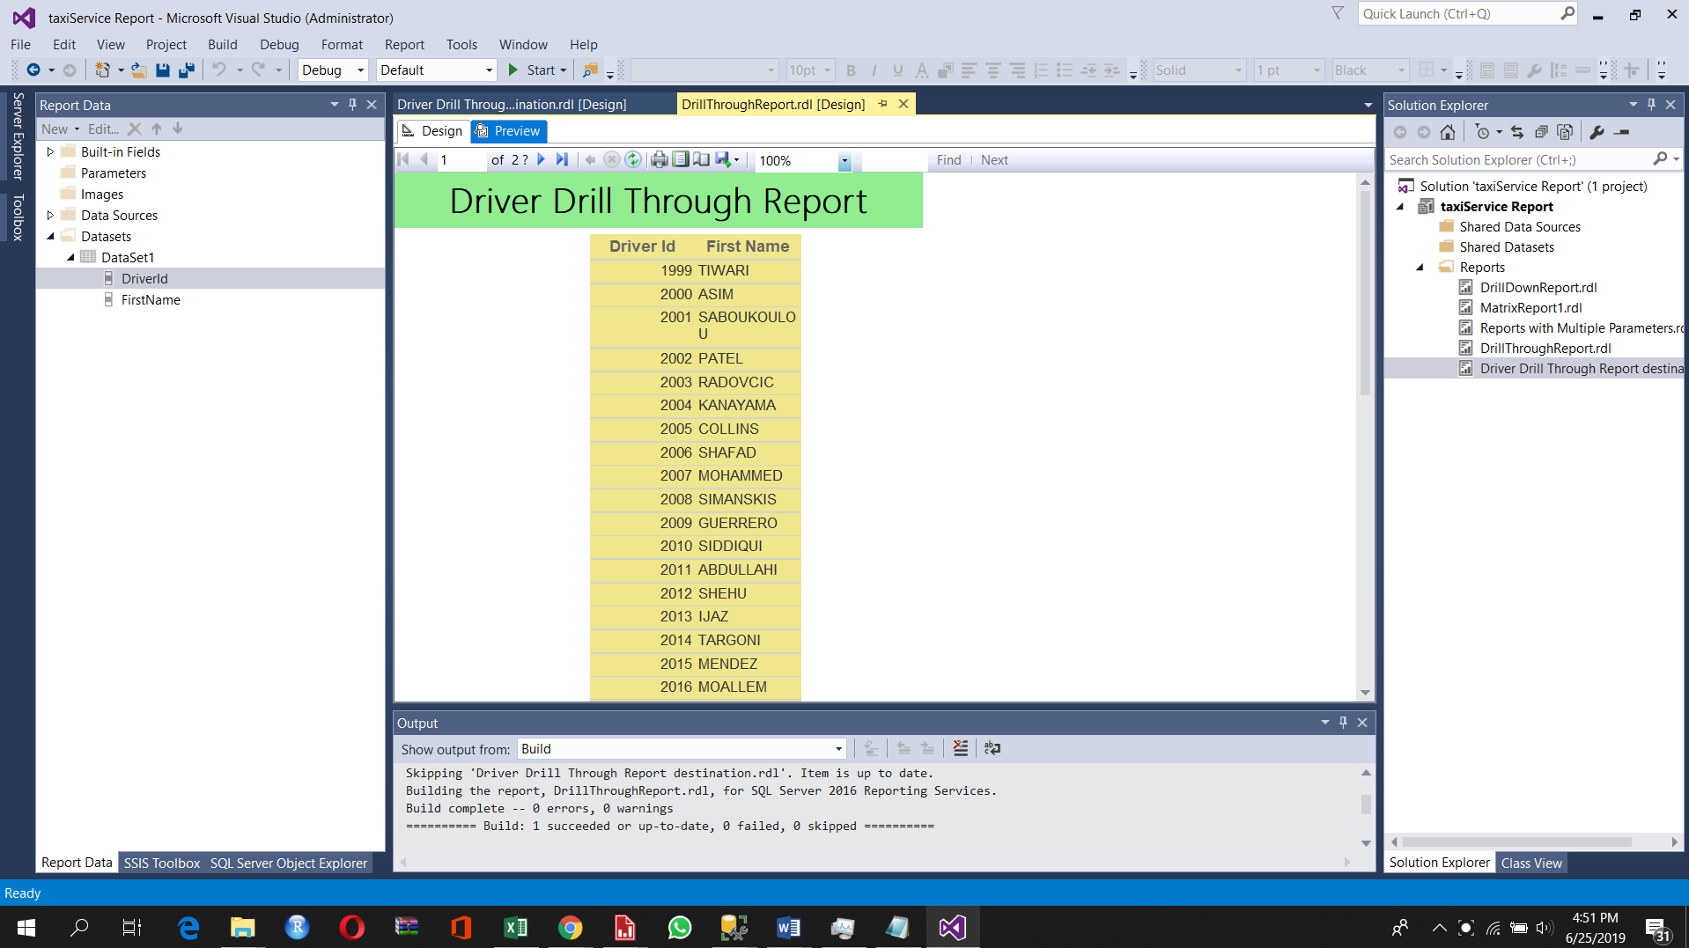

Then Displa clear details about that selected driver’s total hire amount, customer review score like wise information and that all information can drill down according to the Year -> Month -> week of month -> Day of week.

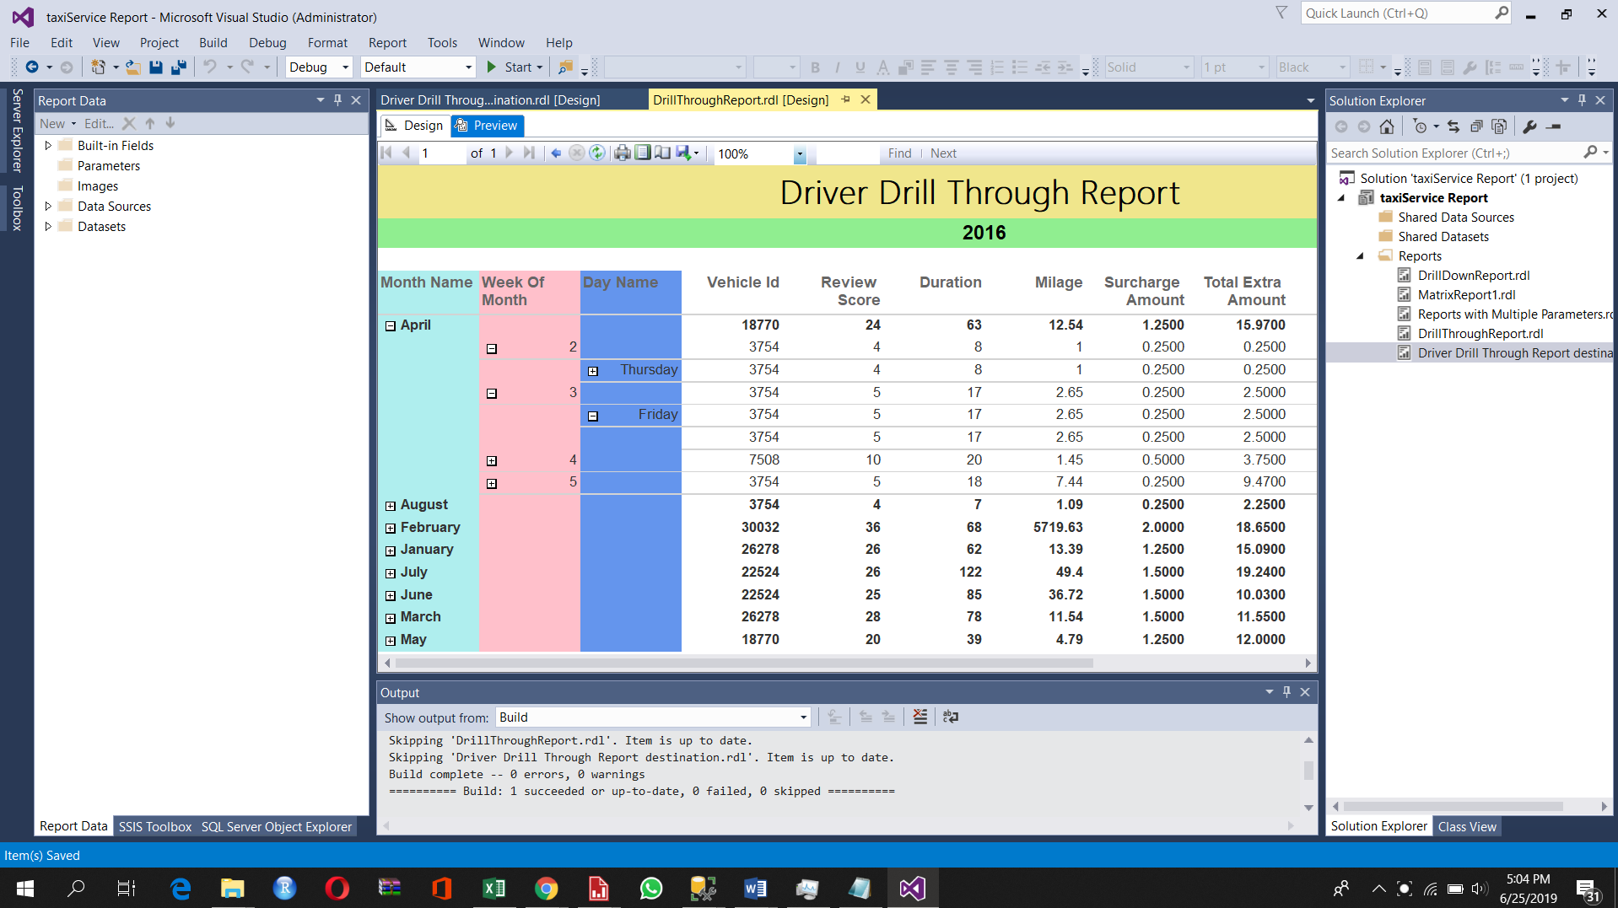

Deployed to portal

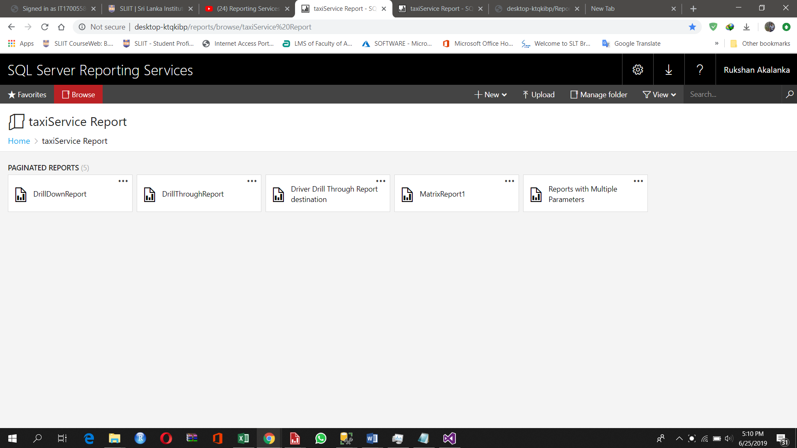

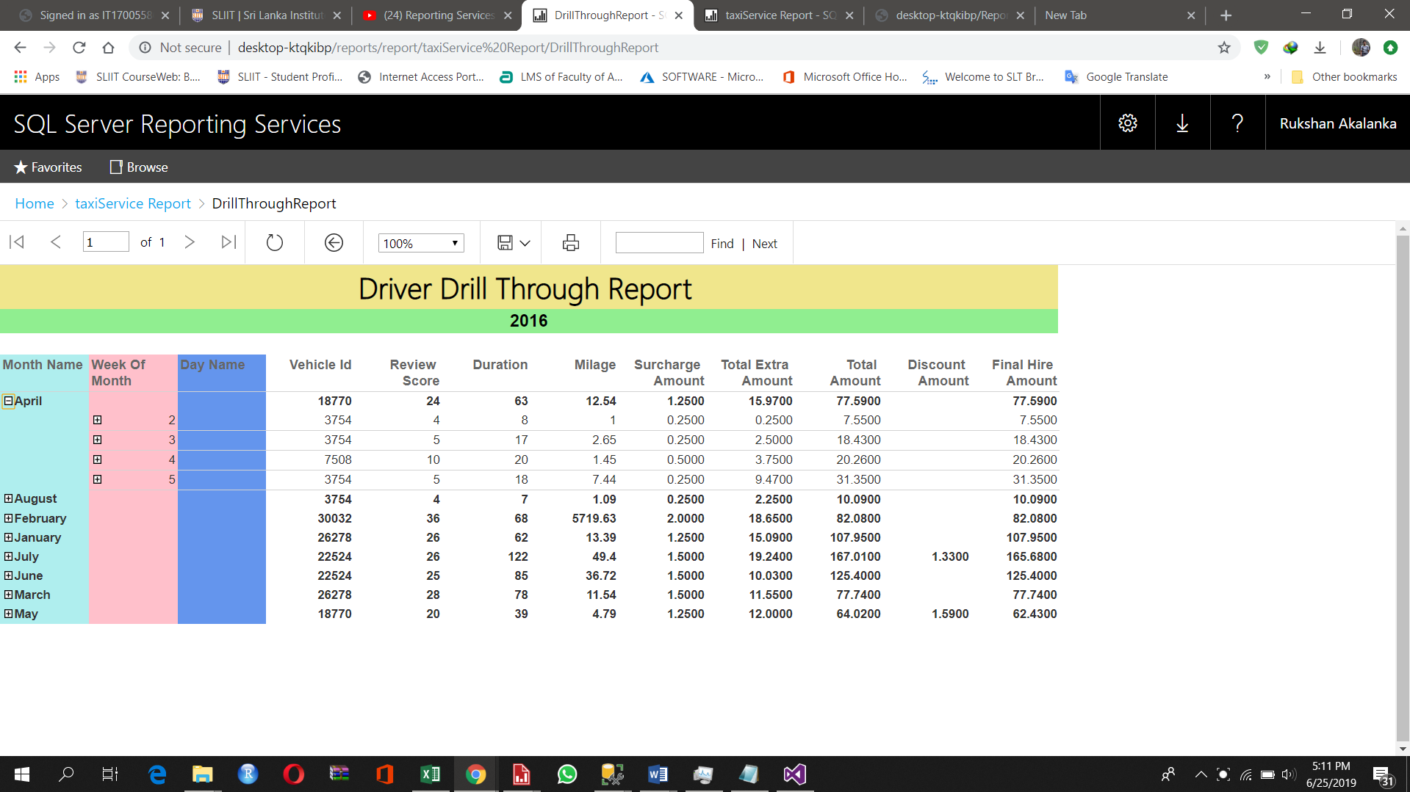

**…END…**